PUBLIC MEETING NOTICE
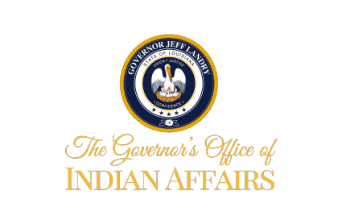
NATIVE AMERICAN COMMISSION MEETING
September 26, 2025
2:30-3:30 p.m.
AGENDA
Chairman, Thomas Rivers
Vice Chairman, Devon Parfait
Secretary, Debbie Garrett

- Call to Order
- Roll Call
- Public Comments
- Announcement of future commission meeting dates
- Meeting speaker ideas for next year
- Adjournment

